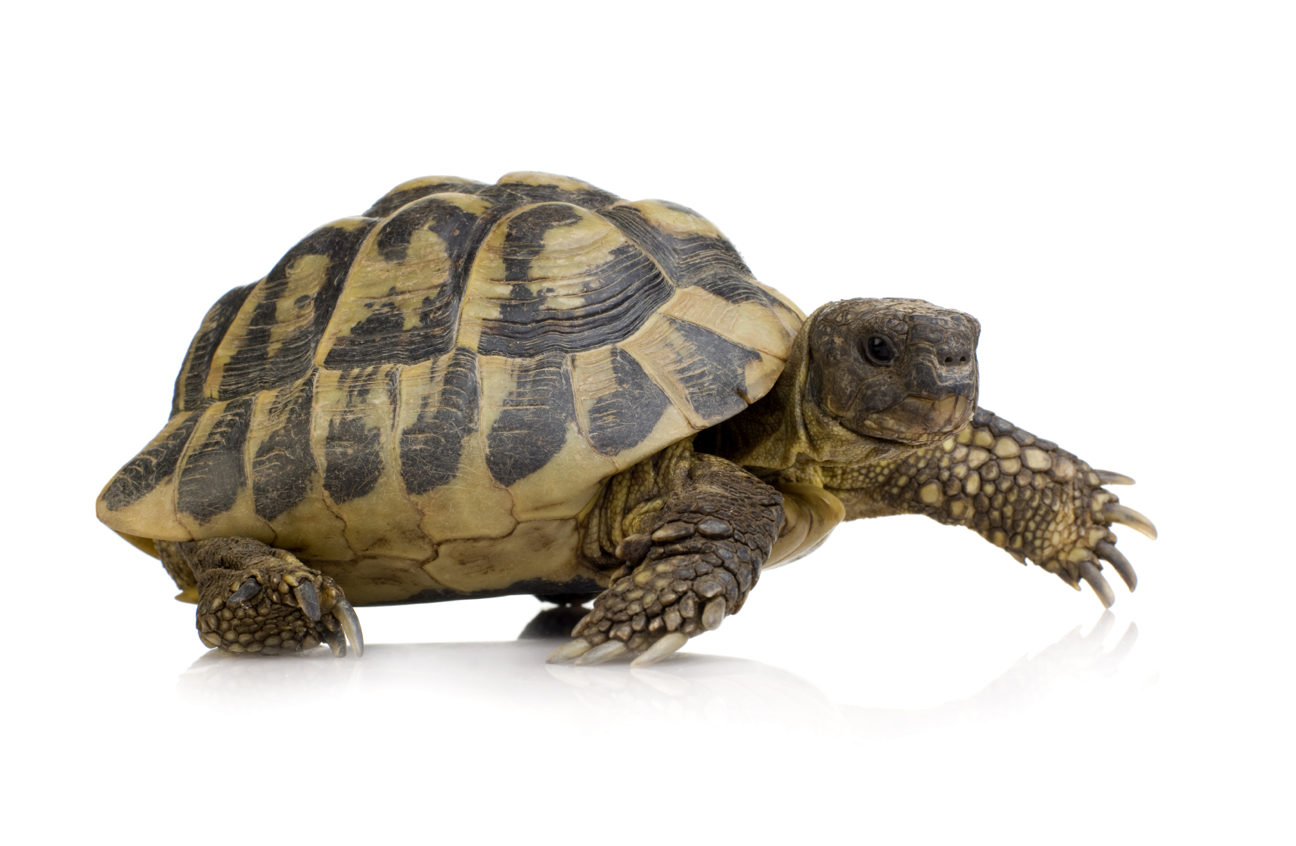

Why does SLOW-DOWN and SLOW-UP   
mean the same thing?



Why does SLOW-DOWN and SLOW-UP   
mean the same thing?

[Firm Name]

[Address]

[City, State Zip]

**[Name]**

**[Address]**

**[City, State Zip]**

[Firm Name]

[Address]

[City, State Zip]

**[Name]**

**[Address]**

**[City, State Zip]**