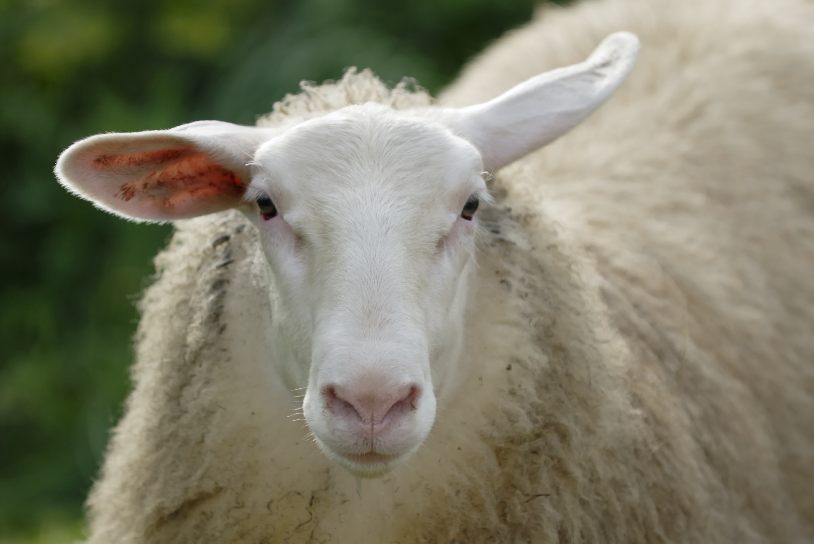

Why don’t sheep shrink when it rains?



Why don’t sheep shrink when it rains?

[Firm Name]

[Address]

[City, State Zip]

**[Name]**

**[Address]**

**[City, State Zip]**

[Firm Name]

[Address]

[City, State Zip]

**[Name]**

**[Address]**

**[City, State Zip]**