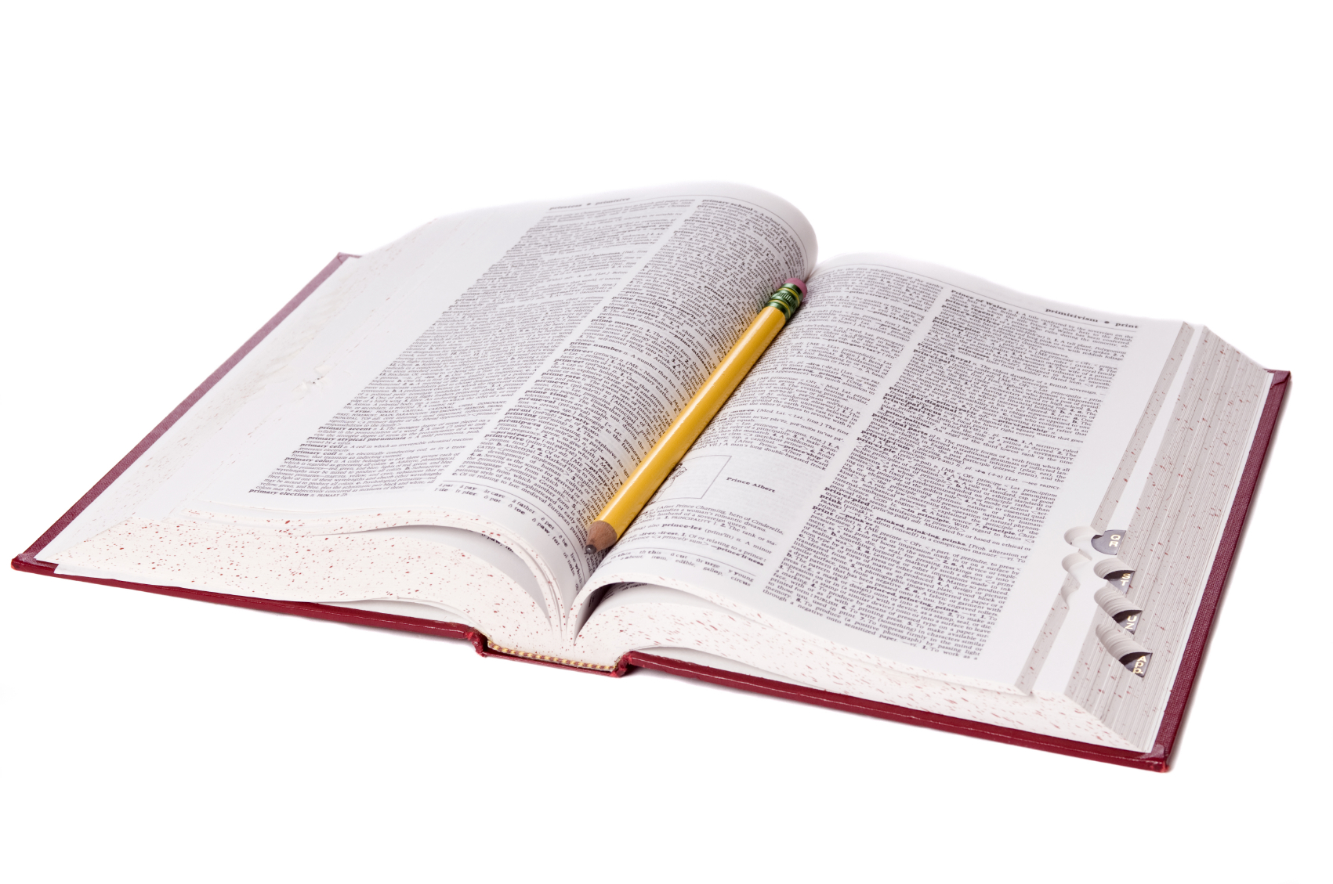

IF A WORD IS MISSPELLED IN THE DICTIONARY  
…HOW WOULD YOU EVER KNOW?



IF A WORD IS MISSPELLED IN THE DICTIONARY  
…HOW WOULD YOU EVER KNOW?

[Firm Name]

[Address]

[City, State Zip]

**[Name]**

**[Address]**

**[City, State Zip]**

[Firm Name]

[Address]

[City, State Zip]

**[Name]**

**[Address]**

**[City, State Zip]**