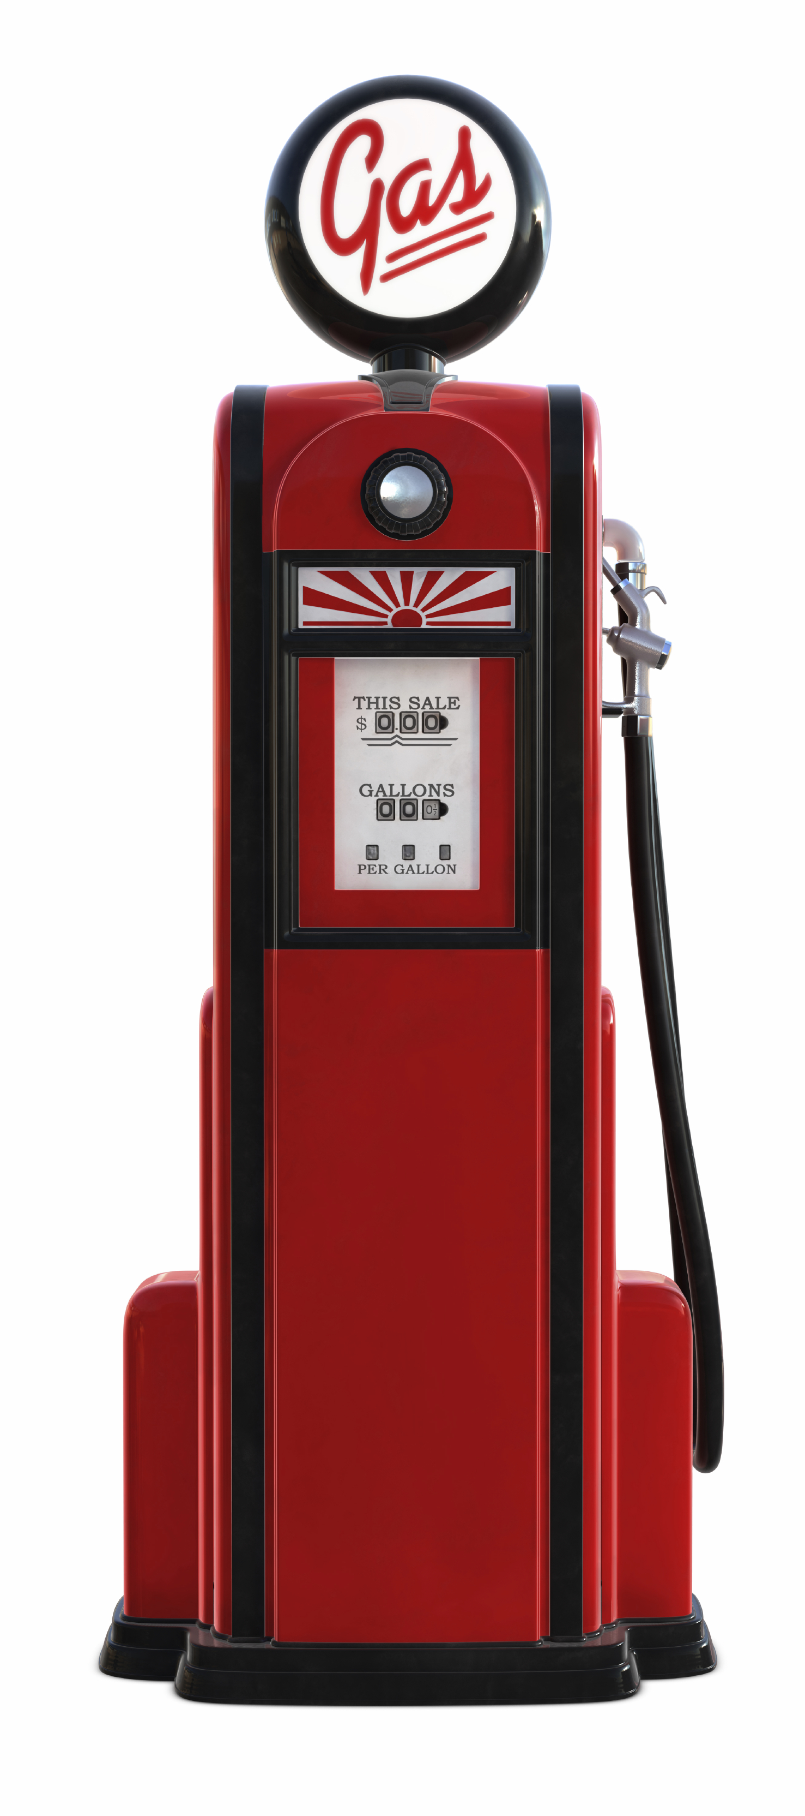

Will driving to a cheaper Gas Station save you?



Will driving to a cheaper Gas Station save you?

If your gas tank holds 12 gallons and your car gets 24 mpg. would it be worth driving another block to save a nickel per gallon of gas? Sure! It would save you 59 cents. Sometimes it’s not so much the savings as the fact that 59 cents would be going into the oil companies pocket instead of yours. It’s the principle of it!

[Firm Name]

[Address]

[City, State Zip]

**[Name]**

**[Address]**

**[City, State Zip]**

If your gas tank holds 12 gallons and your car gets 24 mpg. would it be worth driving another block to save a nickel per gallon of gas? Sure! It would save you 59 cents. Sometimes it’s not so much the savings as the fact that 59 cents would be going into the oil companies pocket instead of yours. It’s the principle of it!

[Firm Name]

[Address]

[City, State Zip]

**[Name]**

**[Address]**

**[City, State Zip]**