**A FRIEND!**

**Invite a friend & join the FUN for our…**

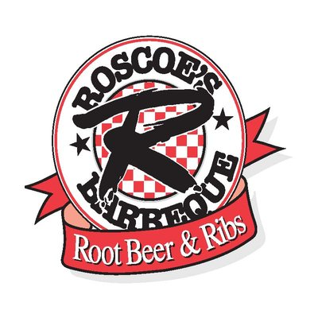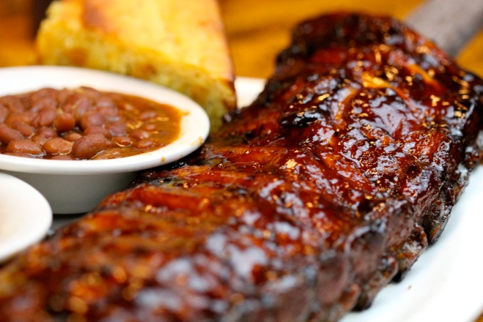

**We’re always looking for   
ways to meet new people JUST LIKE YOU!**

**So what are we asking you to bring?**

**A FRIEND!**

**Invite a friend and join us for a FUN afternoon Client Appreciation party at Garden Marketplatz Perennial Gardens! Enjoy the beautiful summer air, entertaining music, fun door prize drawings and great catered BBQ from Roscoe’s Famous BBQ! And, don’t forget to take a stroll through the beautiful gardens at your leisure. Be prepared for lots of FUN!**

*This is our way of saying “Thank You!” This is not a workshop or a seminar…just a FUN TIME for YOU and a FRIEND to enjoy! So mark your calendars, save the date and join the FUN!*

**Hosted by: John Smith  
Smith & Associates**

**Garden Walks**

3rd Annual Client Appreciation Event

**Picnic Lunch**

**Fun Music**

**Prizes!**

**WHEN: Thursday, June 26th**

**WHERE: Garden Marketplatz** *(123 Anywhere Street)*

**TIME: 11:00 AM – 2:00 PM**

**Please RSVP by: June 19th *(so we can plan for food)***

**Call: (XXX)-XXX-XXXX**